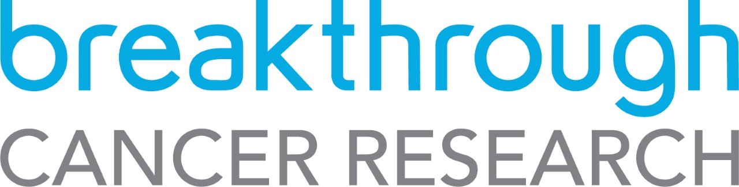

Breakthrough Cancer Research
Summer Student Scholarship

Call for Submission of Applications

KEY DATES

Scholarship Announcement 6th January 2022
Informal Inquiries 6th January – 1st March 2022
Deadline for submission of applications 4th March 2022 17:00 (GMT)
Interviews (Skype Maybe used) April/May 2022
Scholarship Commences June 2022

Terms of Reference

While every effort has been made to ensure the accuracy and reliability of this document, it is provided for information purposes only and as a guide to expected developments. It is not intended, and should not be relied upon, as any form of warranty, representation, undertaking, contractual, or other commitment binding in law upon Breakthrough Cancer Research (Breakthrough). Breakthrough Terms and Conditions of Research Grants shall govern the administration of Breakthrough grants and awards to the exclusion of this and any other oral, written, or recorded statement.

All responses to this Call for Submission of Proposals will be treated in confidence and no information contained therein will be communicated to any third party without the written permission of the applicant except insofar as is specifically required for the consideration and evaluation of the application or as may be required under law.

1. Introduction
The Breakthrough Cancer Research Summer Student Scholarship is an initiative to facilitate the partnership of students with research teams and to foster the education of the next generation of cancer research leaders. Funding will be provided for 4 individual Scholarships, for the period of 6-10 week and to the value of €2,500 each. The scholarships are to take place at any University in Ireland currently engaged in cancer research. It is open to researchers in Clinical, Biological, Epidemiologic, Public Health or Allied health fields. Proposals must fulfil our research priorities, be patient focused, with the ultimate aim to improve cancer care and increase survival.

2. Scholarship Details

2.1 About Breakthrough Cancer Research
Breakthrough is an Irish medical cancer research charity, which aims to inspire and enable financial support for exceptional research into cancer in Ireland leading to more effective treatments for patients in Ireland and Internationally and to improve cancer care and patient survival. To this end we work closely with clinicians in practice all over Ireland so that our research is targeted at finding new options for poor prognosis and currently incurable cancers.
Our focus is on:
- funding world-class cancer research into poor prognosis cancers, which are poorly served by current treatment options
- facilitating collaboration between scientists and clinicians across Ireland and Internationally
- translating lab discoveries into new effective treatments for cancer patients today, tomorrow and into the future
This new Summer Scholarship programme will further promote and drive more patient focused cancer research within Ireland, through education of the next generation of cancer researchers.
- Click here for information on our current research priorities.
- Click hear for some of our current and recently funded research projects.

2.2 Scholarship Details

The Breakthrough Cancer Research Summer Student Scholarship is for students who have completed the 3rd or 4th year of their degree in June 2021. We are looking for high-achieving dynamic individuals, with drive and passion for patient focused cancer research, who are looking for research opportunities aimed at having an impact on patient care and survival.

2.3 Eligibility Criteria of Applicant

All eligible applicants to the Breakthrough Cancer Research Summer Student Scholarship call must meet the following eligibility criteria:
- Successful applicants will be expected to have an average first or upper second class honours average.
- Applications will not be accepted from persons currently registered as PhD students.
- English Language Requirements - please ensure you fulfil the English Language requirements of the relevant host University.
- Each potential supervisor can support one student application only.
2.4. Research Body Requirements

For the duration of the award, the space and infrastructure required to enable the research programme to be undertaken should be made available by the host institution where the Applicant will be registered.

2.5 Funding

The Breakthrough Cancer Research Summer Student Scholarship has a maximum value of €2,500 direct costs for a period of 6-10 weeks (June to September 2021). General overheads are not provided.

The budget requested should include a student stipend of the postgraduate student and costs for their consumables.

Consistent with all other grant awards, Breakthrough will not pay overheads or indirect costs associated with this grant award.

2.6 Proposal Review Process and Evaluation Criteria
- Applications will not be assessed if they are incomplete i.e. an incomplete application form, supervisor form and/or the academic reference forms not supplied, or application is received after the advertised closing date.
- Completed applications will be assessed by a panel of reviewers.
- The panel will consist of a number of reviewers with experience of similar review processes.
- The applications will be assessed under four main headings which reflect the main sections of the application process.
- Reviewers will consider all four elements of the application and allocate scores as follows:
- Academic Qualifications (max. 25 points)
- Personal Statement (max. 25 points)
- Research Proposal (max. 25 points)
- Alignment with Breakthrough Strategy & Potential Impact on cancer (max. 25 points)
- Shortlisting of applicants will be undertaken by the panel of reviewers.
- All shortlisted candidates will be interviewed.
- The Interview will include a short (3 min) lay presentation by the applicant on their proposed research project followed by questions from the panel.

Breakthrough reserves the right to modify the review process. Applicants will be notified of any relevant modification to the review procedure.

3. Application Procedure

3.1 Informal Inquiries
Between the posting/advertising of the Scholarship and the deadline for submission of applications, informal inquiries can be made to research@breakcancer.ie.

3.2 Submission
Completed applications must be submitted by 17:00 (GMT) 25th February 2021 to research@breakcancer.ie.

3.3 Short Listing
A short list of applicants will be invited for interview including a short presentation on their research project as outlined above.

3.4 Budget
The costs eligible for the Breakthrough Cancer Research Summer Student Scholarship are those costs that can, uniquely and unambiguously, be identified with the proposed research programme. Applicants must give details of all relevant costs, including student stipend, materials and consumables and travel. Ensure that the final total provided includes all costs. All awards are made directly to the applicant’s host Institution.

The Scholarship award funds to a maximum value of €2,500 direct costs for a period of 6-10 weeks.

• Equipment
As Scholarship applicants will have access to laboratory space and standard equipment within their host university, it is not expected that applicants will require significant items of equipment in their budget request.

• Materials and Consumables
An outline of all materials and consumables that will be used in the course of the research programme should be provided.

Access charges may be sought for use of infrastructure where pre-approved access charge plans are in place. Note that these may include, with Breakthrough approval, access to facilities and services not available to the applicant, such as the costs associated with accessing international databases or commissioning specific experiments in national facilities (e.g., Tyndall NAP, CRANN etc.).

Access charge requests must be included as a separate line item in the budget and where relevant must include the grant code and name of the relevant infrastructure to be used. A rationale for the amount of use proposed must be provided in the budget justification.

• Travel
Only travel costs for journeys directly related to the progress of the research programme may be requested as a direct cost on the research grant.

3.7 Declaration

It should be noted that submission of an application represents agreement from the applicant to the Breakthrough Terms and Conditions of Research Grants. The applicant must understand acceptance of these term and conditions will be required before funding is provided.

3.8 Deadlines

Applicants must submit their application documents and research proposals by 17:00 (GMT) 25th February 2021. Applications cannot be submitted after this deadline.

4. Award Management

4.1 Reporting Requirements

Breakthrough has stringent requirements for the reporting on awards that it makes. Individuals who hold the primary responsibility for reporting and who fail to comply with reporting requirements, run the risk of having their grant payments suspended and their eligibility to apply for funding in forthcoming Breakthrough calls affected. Reporting is inclusive of annual reporting, Sharing of Research Outputs and the completion of a Researcher Snapshot. There will be an end of term reporting requirement for this scholarship, signed by the student and their supervisor.

The support of Breakthrough Cancer Research must be acknowledged in all publications.

5. Further information

Informal inquiries should be made to research@breakcancer.ie

