CANCER RESEARCH PhD SCHOLARSHIP 2024

GUIDE TO THE ONLINE GRANT MANAGEMENT SYSTEM FOR SUPERVISORS AND ACADEMIC REFEREES

Key Dates
Fellowship Announcement | 12th January 2024
Informal Inquiries Deadline | 15th March 2024
Submission of Proposals Deadline | 22nd March 2024
Submission of References Deadline | 29th March 2024
Interviews and Formal Offer | May/June 2024
Scholarship Commences | September/October 2024

Table of Contents
INTRODUCTION 3
HELP WITH TECHNICAL ISSUES 3
LOGGING INTO THE ONLINE SYSTEM 3
COMPLETING YOUR SECTION OF THE FORM 4
SUBMITTING YOUR SECTION OF THE FORM 5

INTRODUCTION
You have been named as a Supervisor/Co-Supervisor/Academic Referee by a Breakthrough Cancer Research (Breakthrough) grant Applicant. This document is provided to assist you in submitting your section of the application form for the 2024 round of the Cancer Research PhD Scholarship scheme; please read it carefully. Breakthrough will only accept forms submitted through our online Grant Management (GM) system. Please do not send your form to us by email or in hard copy.

The Cancer Research PhD Scholarship scheme is governed by the 2024 Call Document, Terms and Conditions and award acceptance contract. The content of this guide is for general information purposes only. In the event of a discrepancy arising between this guide and the Call Document, Terms and Conditions or award acceptance contract, the latter documents will prevail.

HELP WITH TECHNICAL ISSUES
- Please ensure that the email address ‘Breakthrough Cancer Research noreply@optimytool.com’ is on your ‘safe senders’ list. You may need to check with your IT department to ensure there is no issue with your organisation’s internal firewall.
- Please note, email correspondence from our GM system may arrive in your Spam folder. Links will not be accessible unless you move the email to your Inbox.
- If you experience any technical issues, please clear the cache in your browser and continue. If the issue persists, please contact research@breakcancer.ie.
Please include;
- the name of the Applicant and
- the title of their application, along with a screenshot of any error message (where applicable).

LOGGING INTO THE ONLINE SYSTEM
- When you register for the first time, you will receive an email containing your username (which is your email address), a link to set your password and activate your account, and a link to the login page. Please use the same email address that the Applicant provided when entering your details in their application form to set-up your account.
- Once your account has been created you will receive a second email, which contains a link to your account details.
- If you have lost or forgotten your password, navigate to the login page and click ‘Lost password?’. Once you have entered your email address a link will be sent to you in order to generate a new password. If you do not receive this email, please check your Spam folder. Please note, it may take up to 15 minutes to receive the email containing your new password.
- You will not be able to submit your section of the application form until the Applicant has invited you to do so.

COMPLETING YOUR SECTION OF THE FORM
- Once the Applicant has invited you to contribute to their form, you will receive an automated email. This contains a link that will bring you to the part of the form that you have to complete.
- Please follow the instructions that are provided for you on screen (please see screenshots below).
- SUPERVISORS/ CO-SUPERVISORS must provide:
  - Their contact details
  - The number of PhD students they have successfully supervised
  - Their five most relevant publications
  - Their five most relevant grants
  - Confirmation that the information they have provided is true and correct in the declaration section
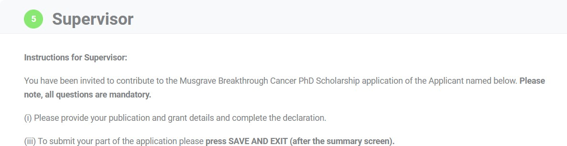

- ACADEMIC REFEREES must provide:
- Their contact details
- An evaluation of the Applicant
- A description of the Applicant’s research potential
- Confirmation that the information they have provided is true and correct in the declaration section
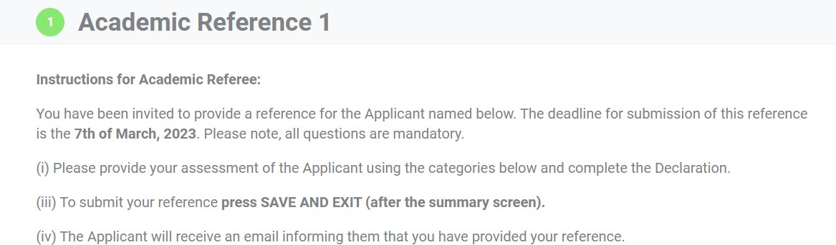

- The information you provide is an essential element of the application, and all sections should be completed in full. If necessary, you can click the ‘SAVE AND EXIT’ button (see screenshot below), which enables you to save the information you provided and return to the form at a later time.
- Once you have completed your section of the form, please click the ‘NEXT SCREEN’ button (see screenshot below), which will bring you to a Summary screen. Any mandatory sections that you have missed will appear in red on the Summary screen (see screenshot example below).

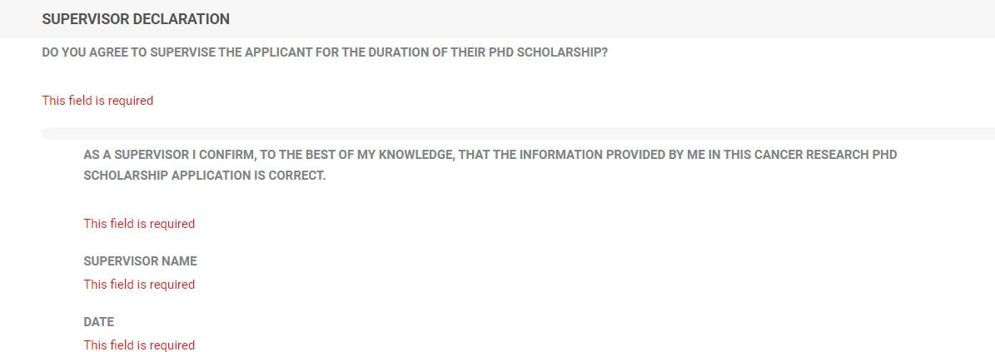

SUBMITTING YOUR SECTION OF THE FORM
- Once you have completed your form, please click ‘SAVE AND EXIT’, which will submit your part of
the form.

- Supervisors and Co-Supervisors: Please note that (i) the Applicant has access to the information you have entered in your part of the form (ii) the Applicant will not be able to submit their application form until you have completed and submitted your sections. The application deadline is the 22nd of March 2024.
- Academic Referees: Please note that (i) the Applicant does not have access to the information you have entered in your part of the form (ii) the Applicant will not be able to submit their application form until you have completed and submitted your reference. We are requesting that Referees submit their references by the 28th of March 2024 to enable the Applicant to submit the references by the deadline of the 29th of March 2024.

