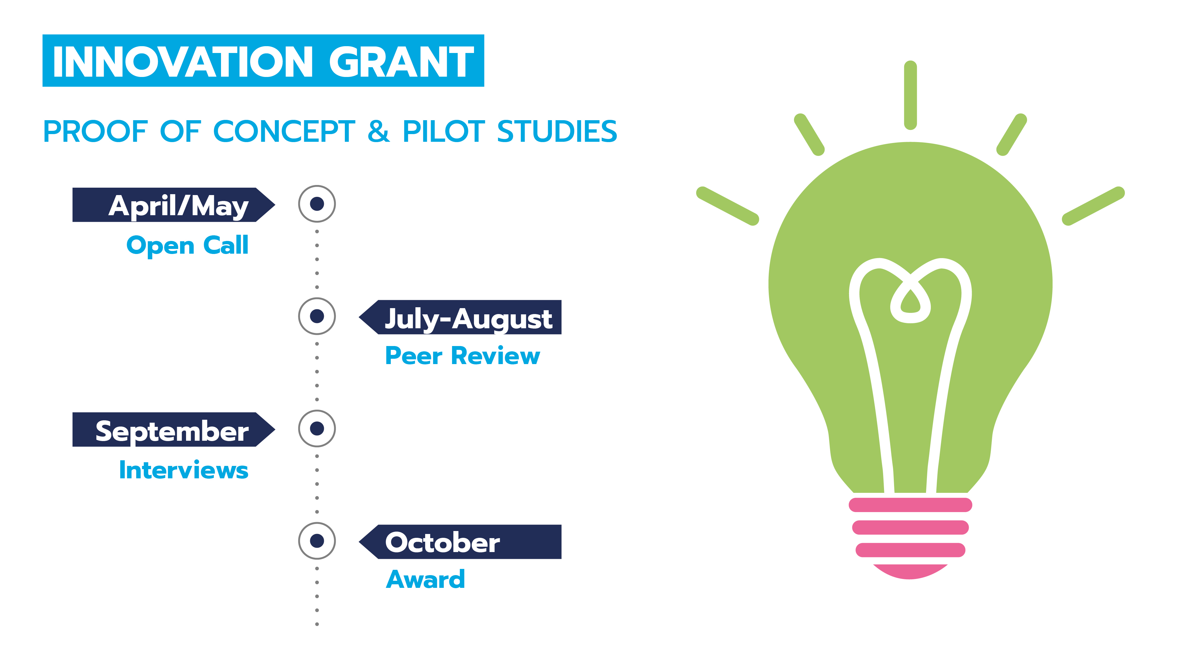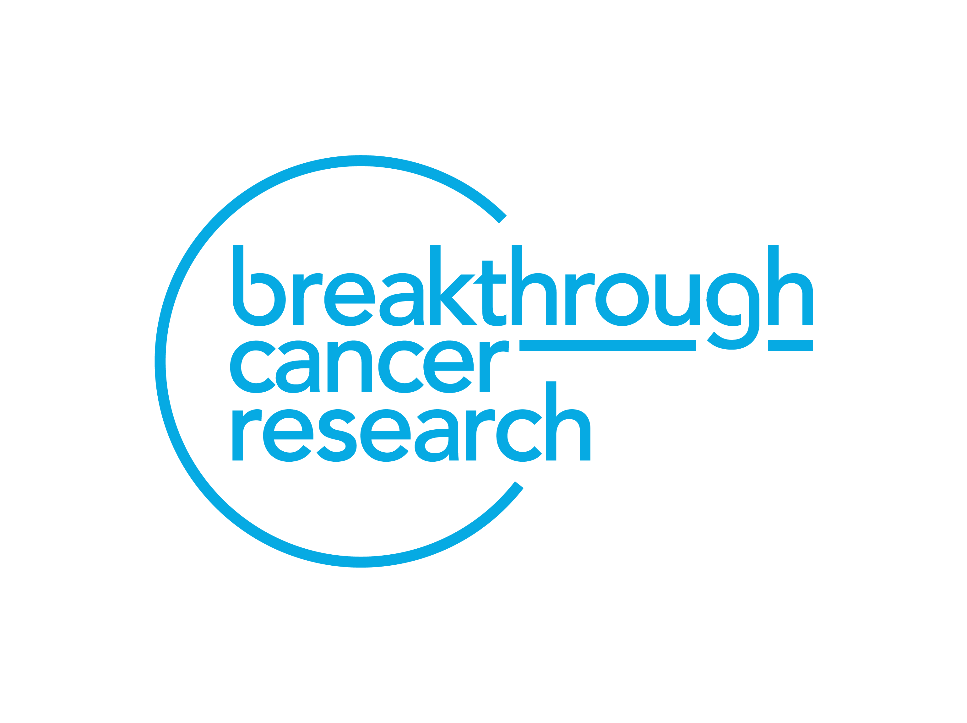

**Breakthrough Cancer Research Innovation Grant Programme**

*In partnership with*

**City Ireland, Ovacare and Royal London Ireland**

**Call for Submission of Applications**

|  |  |
| --- | --- |
| **KEY DATES** | |
| **Grant Announcement** | **25th February 2024** |
| **Grant Launch** | **20th May 2024** |
| **Informal Inquiries** | **12th July 2024** |
| **Application Deadline** | **15th July 2024 14:00 (Irish Time)** |
| **Panel Review** | **July - September 2024** |
| **Interviews/final selection** | **September 2024** |

**Terms of Reference**

While every effort has been made to ensure the accuracy and reliability of this document, it is provided for information purposes only and as a guide to expected developments. It is not intended, and should not be relied upon, as any form of warranty, representation, undertaking, contractual, or other commitment binding in law upon Breakthrough Cancer Research (Breakthrough). Breakthrough Terms and Conditions of Research Grants shall govern the administration of Breakthrough grants and awards to the exclusion of this and any other oral, written, or recorded statement.

All responses to this Call for Submission of Proposals will be treated in confidence and no information contained therein will be communicated to any third party without the written permission of the applicant except insofar as is specifically required for the consideration and evaluation of the application or as may be required under law

**1. Introduction**

**1.1 About Breakthrough Cancer Research and Partners**

Breakthrough Cancer Research is an Irish medical research charity focused on cancer. We work to significantly impact the number of children and adults who can survive this disease. We invest in world-class research in Ireland and beyond to impact the quality of life for people with cancer and save lives. We are particularly focused on improving outcomes for those cancers, which are poorly served by current treatment options.

In 2022 we launched ‘Making More Survivors’ - Our Research Strategy 2022 - 2027 which sets out how, through research, we plan to significantly impact the survival rates of the poorest prognosis cancers over the next five years. We passionately believe in the power of research to transform cancer care and the patient experience, having already delivered new treatments with our find smart, fund fast approach.

Our focus on the poorest prognosis cancers means we need to urgently have impact to remove the disparity in cancer survival rates between the so called ‘good’ cancers and ‘bad’ cancers. This strategy reflects our ambitious vision to strive for 100% survival for 100% of cancers through cutting edge patient-focused translational research at every point of the cancer journey. New diagnostics and better treatments are urgently needed. Building capacity and embedding research into the health system will increase the number of people who survive a cancer diagnosis and improve their quality of life during treatment and beyond.

Our core focus over the next five years of the strategy will be to:

• Target greater research investment into the poorest prognosis cancers, which are poorly served by current treatments

• Accelerate the translation of lab discoveries into new effective treatments for people with cancer

• Facilitate greater collaboration between scientists and clinicians across Ireland and internationally

• Build expertise and capacity to move from bench to bedside and from cancer patients back to the laboratory

• Focus on keeping the patient at the centre of all of our activities

This programme will further promote and drive more patient-focused cancer research and innovation within Ireland.

**2. Innovation Grant Programme Details**

The Breakthrough Cancer Research Innovation Grant Programme 2024 is in partnership with **Citi Ireland**, **OvaCare**, and **Royal London Ireland** which represents new partnerships to fund world class cancer research in Ireland.

**2.1. Scope**

Funding for Grants, focused on **proof of concept** or **pilot studies** will be provided to take place at any University in the Republic of Ireland currently engaged in cancer research.

A **proof of concept** study is a realisation of an idea, method or principle in order to demonstrate its feasibility, or viability, or a demonstration in principle with the aim of verifying that some concept or theory has practical potential.

A **pilot study** is a small feasibility study designed to test various aspects of the methods planned for a larger, more rigorous, or confirmatory investigation.

The Breakthrough Innovation Grants forms part of our strategy to make more survivors of cancer through research and facilitating cutting-edge cancer innovations, essential to improve early diagnosis, treatment, and survivorship (recovery and patient experience). Through this programme we encourage researchers to initiate, identify and develop innovations and to adopt and implement evidence-based innovative approaches across the disease trajectory.

Applications must align with Research strategy [Our Research Strategy - Breakthrough Cancer Research and research priorities](https://breakthroughcancerresearch.ie/our-research-strategy/), be patient-focused with the ultimate aim to improve cancer care and increase survival.

**2.2. Who can apply?**

Funding for Grants, focused on **proof of concept** or **pilot studies** will be provided to take place at any University in the Republic of Ireland currently engaged in cancer research. This programme is open to independent researchers across disciplines from **lab-based** to **applied research** and **allied health**, across the disease trajectory from; prevention, to early diagnosis, treatment or survivorship.

Applicants are not required to hold a permanent position to apply but do need to have a contract with the host institute for the duration of the grant application. A **letter of support** from the host institution confirming support and employment status will be required from applicants without a permanent position.

Applicants without a permanent position should also give details of a permanent academic staff member who will act as a **Mentor** for the duration of the award.

**2.3. Research team**

The research team will comprise of a Principal investigator who will have overall responsibility for the management of the grant application. Co-applicants and collaborators, including Public Patient Involvement and Engagement (PPIE) partners are encouraged to a maximum of **three co-applicants** and **five collaborators**.

**2.4. Funding Priorities**

There will be two Innovation Grant streams.

**Stream 1:** Applications are invited for innovative pilot or proof of concept studies focused on awareness of symptoms, early detection, treatment or interventions to improve survivorship focused on cancer sites with the lowest survival: pancreatic, oesophageal, lung, brain, stomach, liver cancer, multiple myeloma or uveal melanoma.

**Stream 2:** in partnership with **OvaCare** ([Ovarian Cancer community ¦ Risk factors ovarian cancer ¦ cancer advocacy (ovacare.ie)](https://ovacare.ie/)) applications are invited for innovative pilot or proof of concept application focused on ovarian cancer; increased awareness of symptoms, early detection, treatment, or interventions to improve survivorship.

**2.5. Funding**

Each award will be up to a maximum value of **€50,000** for the maximum **duration of 12-18 months**. All awards are made directly to the applicant’s host Institution.

**2.5.1. Fees and salaries**

The budget requested should **not** **include postgraduate fees or stipend**. Salary remuneration up to a max of €30 k across the lifetime of the grant will be considered.

**2.5.2. Materials and consumables**

Costs of all materials and consumables must be uniquely and unambiguously identified with the proposed research programme and justified. No personal equipment for example; Laptops or laboratory equipment can be purchased as part of this award.

**2.5.3. Travel**

Only travel costs for journeys directly related to the progress of the research programme may be requested as a direct cost on the research grant. The applicant should outline the details of travel expenses directly related to, for example, conferences, scientific collaboration on the research programme, or learning special research techniques. Where possible, please supply the conference name and location. In the case of working visits, the rates sought for subsistence and other allowances may be no more than those which the research body’s permanent staff may claim.

**2.5.4. Publication costs**

Costs for publication of peer-reviewed research findings may be requested as part of the Breakthrough Innovation Grant 2024. All requests must be justified.

**2.5.5. Overhead costs**

Consistent with all other grant awards, Breakthrough will not pay overheads or indirect costs associated with this grant award.

**2.5.6. Other funding sources**

Breakthrough will not fund research proposals which have already been funded by another funding body. Please provide details of all other financial support available for this or other similar projects, and if you have submitted this application or a similar application to another funding body, please provide details on the project title, funding body and the amount of the award.

**2.6. Duration**

The Breakthrough Cancer Research Innovation Grant award is for a maximum **duration of 12-18 months**.

**2.7. Research Body Requirements**

For the duration of the award, the space and infrastructure required to enable the research programme to be undertaken should be made available by the host institution where the Applicant will be registered.

**2.8. Ethical approval**

If your proposal involves human participants or human material or animals, please provide evidence that ethical approval has been obtained. If you are in the process of applying for ethical approval, please provide details of the Ethical Committee from which you will seek approval.

**2.9. Submission**

A lead applicant or the Principal Investigator will apply. Co-applicants and collaborators are encouraged but to a **maximum of three co-applicants** and **five collaborators**. The lead applicant will submit the application on behalf of the research team. Completed applications must be submitted by **15th July 2024 14:00 (Irish time)** through the [Breakthrough Cancer Research Grant Management System](https://grants.breakthroughcancerresearch.ie/en/). **Applications cannot be submitted after this deadline**.

**2.10. Proposal Review Process and Evaluation Criteria**

* Applications **will not** be assessed if they are **incomplete** or received after the advertised closing date.
* Completed applications will be assessed by a panel of reviewers, including public patient involvement (PPI) reviewers.
* The panel will consist of a number of reviewers with experience of similar review processes.
* The applications will be assessed under four main headings which reflect the main sections of the application process.
* Reviewers will consider all four elements of the application and allocate scores as follows:
* Innovation and novelty of the application
* Potential Impact of the application
* Potential of the principal investigator and team to complete the proposal successfully
* Alignment with Breakthrough Strategy & Potential Impact on cancer
* All shortlisted candidates will be interviewed.
* The Interview will include a short (5min) lay presentation by the applicant on a relevant research topic followed by questions from the panel.

**Breakthrough reserves the right to modify the review process. Applicants will be notified of any relevant modification to the review procedure.**

**3. Award Management**

**3.1. Reporting Requirements**

Breakthrough has stringent requirements for the reporting on awards that it makes Individuals who hold the primary responsibility for reporting and who fail to comply with reporting requirements, run the risk of having their grant payments suspended and their eligibility to apply for funding in forthcoming Breakthrough calls affected. Reporting is inclusive of annual reporting, Sharing of Research Outputs and the completion of a Researcher Snapshot. There will be a final reporting requirement for this grant programme.

**3.2. Acknowledgement of Funding**

All researchers awarded funding from Breakthrough must follow the [Guidelines for Acknowledgement of Funding](https://breakthroughcancerresearch.ie/wp-content/uploads/2024/05/Breakthrough-Cancer-Research-Funding-Acknowledgment-Guidelines.docx).

**3.3. Further information**

Informal inquiries should be made to [research@breakcancer.ie](mailto:research@breakcancer.ie)

**4. Declaration**

It should be noted that submission of an application represents agreement from the applicant to the Breakthrough Terms and Conditions of Research Grants. The applicant must understand acceptance of these term and conditions will be required before funding is provided.