**Breakthrough Cancer Research Innovation Grant Programme**

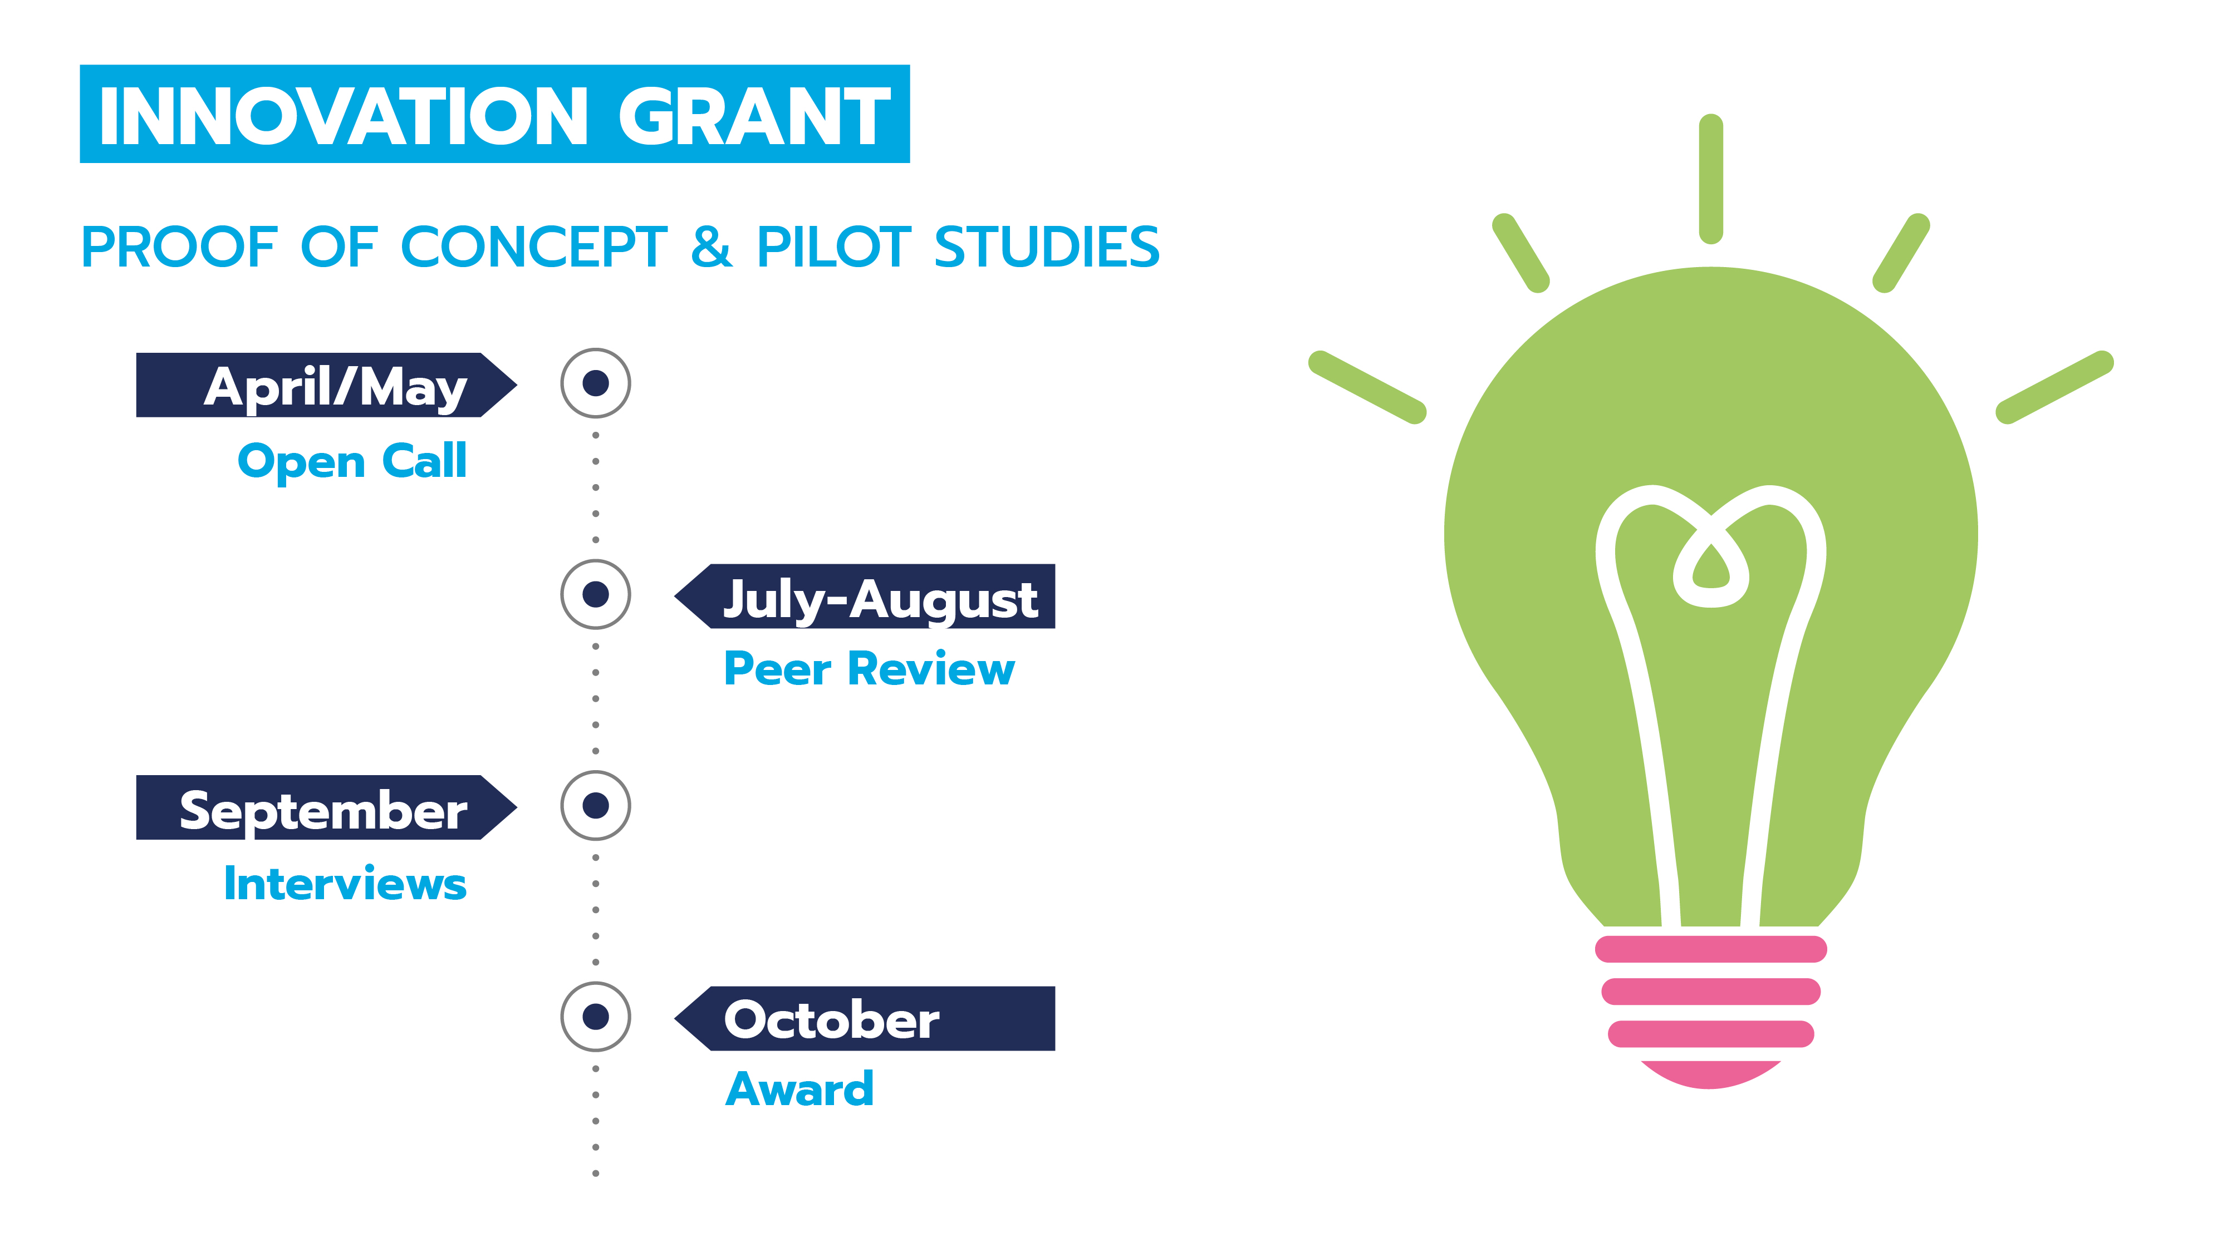

**Application FAQs**

**What steps do I have to take to complete the full application?**

1. Complete the following sections; Research Description, Budget, Host Laboratory Mentor, Host Institution, Co-Applicant Declaration, Collaborator Declaration and the Applicant Declaration.
2. Invite Co-applicants, Collaborators, Mentors, and your Host Institutions(s) to complete their parts of your application form (as detailed below)
3. Upload the Letter(s) of Support from your Host Institution(s) in Section 4 (Research Proposal Details)
4. Once the entire application form is complete (including all sections by your Mentors, Co-applicants, Collaborators and Host Institution), submit by clicking on VALIDATE AND SEND, found at the end of the Summary screen

# Who contributes to my application?

You, the Applicant, along with your Mentors, Host Institutions(s), Co-applicants and Collaborators, who are defined as ‘Contributors’ on the Grant Management system. We recommend that you give your Contributors at least two weeks’ notice to complete their sections of the form, along with sending them reminder emails, when necessary, to avoid missing the submission deadline. Please click into your Contributors’ sections of the form to ensure they have entered all the information necessary to complete your application. Please note, it is your responsibility, as the Applicant, to ensure that all sections of the form are completed before the closing date of the 15th of July 2024.

# How do I invite Contributors to add to my full application?

Please carefully follow these instructions on how to invite your Mentors, Host Institutions(s) Co-Applicants and Collaborators to complete their sections of the form. Please note that you must retain the Mentor, Co-Applicant and Collaborator order throughout your application. For example, Collaborator One in section 4 must be Collaborator One in section 11 (Declaration). This enables pre-population of certain fields in the form.

* 1. Click on the green MANAGE INVITATION button, found at the bottom of the panel on the left of the form
  2. Click INVITE A CONTRIBUTOR
  3. Enter the email address of your Contributor
  4. Tick (i) the section of the form that they must complete AND (ii) the summary screen
  5. From the drop-down list at the bottom of the page, select 'Full Access'
  6. Click INVITE THIS CONTRIBUTOR
  7. If you wish to come back to this step at a later stage, click the CONTINUE button, which will bring you back to the full application

Your Mentors, Host Institution(s) Co-Applicant and Collaborators will automatically receive an email with a link to the relevant part of your application form, which may arrive in their Spam folder. If this does happen, they must move the email to their Inbox in order to access the link to the form.

Your Contributors must then set up an account on our Grant Management system, using the same email address you entered for them.

# What information does my Host Institution have to provide?

Your Host Institution(s) must provide proof of institutional support in the form of a Letter of Support. The Letter of Support can be signed by a senior person from your Host Institution’s Research Office or Finance Office. You the Applicant, must upload this letter in Section 3 (Research Proposal Details). Your Host Institution(s) must also complete the declaration in Section 6 (Host Institute Representative Declaration), confirming that the information in the letter is true and correct. If you plan to conduct your project in two Host Institutions, they must both provide you with a Letter of Support.

# What information does my Mentor have to provide?

Mentors must provide a 500-word statement of support in your application, each clearly outlining how they will support you, the Applicant, throughout the project period. Please note, your Mentor within the laboratory will act as an advisor and host but will not play a supervisory role. This Mentor will work with you to ensure that all fiduciary and ethical approvals, where relevant to the award, are managed successfully. The mentor must also complete their declaration section, confirming that the information they have provided is true and correct.

# What information do my Co-applicants have to provide?

Your co-applicant(s) have to provide the following:

1. Their contact details
2. Their most recent employment
3. Their highest academic qualification
4. Their grant history, including total grant funding received
5. Their five most relevant publications
6. Information on the role they will play in the research project
7. Confirmation that the information they have provided is true and correct in the declaration section

# What information do my Collaborators have to provide?

Your Academic, Clinical and Industrial Collaborators have to provide the following:

1. Their contact details
2. Their most recent employment
3. Their highest academic qualification
4. Their grant history, including total grant funding received
5. Their five most relevant publications
6. Information on the role they will play in the research project
7. Confirmation that the information they have provided is true and correct in the declaration section

Your PPI Collaborators have to provide:

1. Their contact details
2. Information on the role they will play in the research project

Confirmation that the information they have provided is true and correct in the declaration section