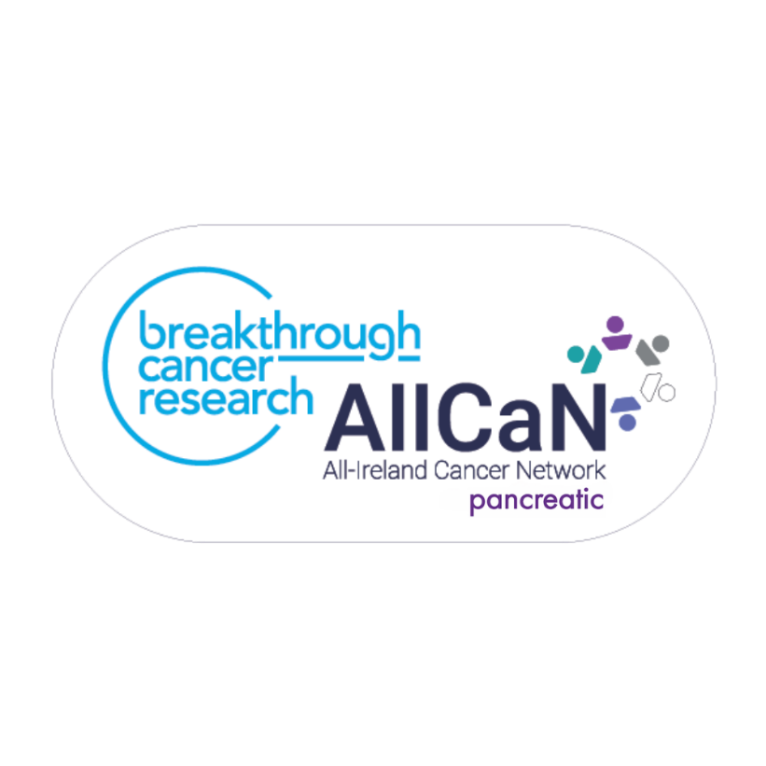
Breakthrough Cancer Research
All-Ireland Cancer Network (AllCaN) – Pancreatic Cancer
Programme Grant 2024

Programme Guidelines and Application Instructions

Table of Contents

Table of Contents 2
INTRODUCTION 3
ABOUT BREAKTHROUGH CANCER RESEARCH 3
KEY DATES 4
THE ALL-IRELAND – CANCER NETWORK (AllCaN) PROGRAMME GRANT 4
AllCaN PANCREATIC CANCER PROGRAMME GRANT 2024 4
PROGRAMME STRUCTURE 5
AllCaN PROGRAMME MISSION STATEMENT 5
AllCaN MEMBER ELIGIBILITY CRITERIA 6
AllCaN Team Composition 7
APPLICATION DEADLINES 8
EVALUATION 8
PROJECT TERMS 10
Changes to application 10
Flow of Funds 11
Budget 11
APPLICATION INSTRUCTIONS 12

INTRODUCTION

ABOUT BREAKTHROUGH CANCER RESEARCH

Breakthrough Cancer Research (Breakthrough) is an Irish medical research charity focused on cancer. We work to significantly impact the number of children and adults who can survive this disease. We invest in world-class research in Ireland and beyond to impact the quality of life (QoL) for people with cancer and save lives. We are particularly focused on improving outcomes for those cancers, which are poorly served by current treatment options.
In 2022 we launched ‘Making More Survivors’ - Our Research Strategy 2022 - 2027 which sets out how, through research, we plan to significantly impact the survival rates of the poorest prognosis cancers over the next two decades, starting with this five year strategy. We passionately believe in the power of research to transform cancer care and the patient’s experience, having already delivered new treatments with our find smart, fund fast approach.
Our focus on the poorest prognosis cancers means we need to urgently have impact to remove the disparity in cancer survival rates between the so-called ‘good’ cancers and ‘bad’ cancers. This strategy reflects our ambitious vision to strive for 100% survival for 100% of cancers through cutting edge patient-focused translational research at every point of the cancer journey. New diagnostics and better treatments are urgently needed. Building capacity and embedding research into the health system will increase the number of people who survive a cancer diagnosis and improve their quality of life during treatment and beyond.
Our core focus over the next five years of the strategy is to:
• Target greater research investment into the poorest prognosis cancers, which are poorly served by current treatments
• Accelerate the translation of lab discoveries into new effective treatments for people with cancer
• Facilitate greater collaboration between scientists and clinicians across Ireland and internationally
• Build expertise and capacity to move from bench to bedside and from cancer patients back to the laboratory
• Focus on keeping the patient at the centre of all of our activities
This strategic funding programme will further our strategic goals through its aim to maximising expertise and resource-building on the island of-Ireland through facilitating multidisciplinary team working towards improved patient outcomes.

KEY DATES

Programme Launch | 27th June 2024
Programme Opened | 9th September 2024
Informal Inquiries | 9th September – 10th October 2024
Deadline for Expression of Interest | 18th October 2024, 12:00 Irish time
Notification of successful team(s) for full applications | November 2024
Deadline for submission of full proposals | December 2024
Interviews of successful teams & Formal Offer | January 2025
Programme commences | Spring 2025

THE ALL-IRELAND – CANCER NETWORK (AllCaN) PROGRAMME GRANT

The All-Ireland – Cancer Network (AllCaN) Programme Grant is a Breakthrough Cancer Research funding programme started in 2021. This Programme Grant will fund networks of the best scientists/researchers at institutions across the Island of Ireland, to develop new and innovative approaches to improving cancer outcomes. Researchers will collaborate across disciplines, institutions, and as appropriate across the four pillars of prevention, detection, treatment and survivorship. The successful researchers will work together on a common goal, pooling their knowledge and resources to work together to eliminate barriers and to hasten the progression needed to improve patient outcomes.

AllCaN PANCREATIC CANCER PROGRAMME GRANT 2024

Pancreatic cancer will be the focus of the AllCaN Programme grant 2024. Annually there are approximately 900 pancreatic cancer cases on the island of Ireland (n=600 in the Republic of Ireland (RoI), n=279 in Northern Ireland (NI)) and 820 pancreatic cancer deaths (n=569 RoI, n=252 NI) according to figures from the National Cancer Registry Ireland (ncri.ie) and Northern Ireland Cancer Registry (NICR; qub.ac.uk). The 5-year survival for pancreatic cancer is extremely low at approximately 14% in the RoI and 8% in NI.
The All-Ireland Cancer research Network (AllCaN) Programme Grant was conceived in 2021 to facilitate the harnessing of research opportunities on the Island of Ireland and to drive improvements in outcomes for people impacted by the poorest prognosis cancers. This strategic funding programme is part of our Research Strategy 2022-2027 which aims to double the survival of people diagnosed with oesophageal, pancreatic, lung, ovarian, gastric, brain and liver cancer over the next two decades. Pancreatic Cancer is the focus of the AllCaN programme 2024. This programme will be up to a maximum value of €1,000,000 and will be awarded in Winter 2024 to commence early 2025 over 3 or 4 years. As a charity, no overheads will be included.

PROGRAMME STRUCTURE

This cancer research funding programme will be led by a Team leader and two co-Team leaders, who are recognised as being international experts in their field, in academic institutions across the island of Ireland. They will use the core programme funding from Breakthrough to build a research programme and a network. A central tenet of this core funding is that it will be used to leverage funding from pharma, academic institutes, other charities and funding bodies. Another key element of this award will be maximizing innovation while minimizing bureaucracy. Breakthrough believe that this programme will advance scientific research in the interests of both today’s cancer patients and those who may develop cancer in the future

AllCaN PROGRAMME MISSION STATEMENT

The Breakthrough AllCaN Programme Funding represents a new, focused effort to implement advances in research into poor prognosis cancers as rapidly as possible through the creation of a collaborative, translational cancer research network.
The most talented and promising researchers across Irish institutions will be assembled into an All-Ireland Cancer Research Network forming an optimal configuration of expertise needed to solve key problems in Pancreatic Cancer research and positively impact patients. This network will span multiple disciplines and utilise their expertise to address research questions in a coordinated way through a new team and a novel research programme.
The network will have mechanisms for sharing of resources and platforms (knowledge, talent, tools, technologies, etc.) across the team including existing platforms and resources as well as those to be developed, incorporating new methods and technologies into the research groups, and training and networking across the network. Mechanisms to foster collaborations within and among the network will be employed, an approach that promotes the sharing of information and a goal-oriented focus on measurable milestones of progress.
In particular, the applicants must:
1. Focus on addressing factors that have the potential to positively impact outcomes; decreasing incidence, improving detection and treatment (see Appendix 1: Pancreatic Cancer Research Landscape)
2. Present a plan for how the Network can create a new National scientific group and plan with an Pancreatic Cancer focus
3. Build a novel All-Island program (i.e., includes Team Principals from AT LEAST three different institutes), which brings together interdisciplinary research groups to answer questions that will significantly advance the field of Pancreatic Cancer research
4. Be integrated and cohesive, based on excellence and innovation, and be highly networked across the country and to include existing platforms and resources, as well as those to be developed;
5. Include mechanisms for sharing resources and platforms (knowledge, talent, tools, technologies, etc.) and developing or incorporating new methods and technologies;
6. Present innovative approaches and integrate advances from other fields or technologies;
7. Include training opportunities for the future generation of scientists and foster an entrepreneurial culture within the community;
8. Demonstrate engagement with industry including; areas of collaboration, sharing of resources and expertise, and provision of co-funding.

AllCaN MEMBER ELIGIBILITY CRITERIA

AllCaN Team Leader: Leader is responsible for the intellectual direction of the proposed research and assumes administrative and financial responsibility for funds which will be paid to their institution.
AllCaN Team Co-Leader: Co-leader should be designated to assist in directing the scientific and technical work of the Team. A Co-leader will serve as an alternate contact person for the funders.
AllCaN Team Principal Investigators. Senior investigators, other than the Leader, Co-leader, who will lead a component(s)/subproject(s). The team must be All-island in nature including Principals Investigators from AT LEAST three different institutes.
Early career non-tenured investigators. Early career non-tenured investigators (i.e. independent investigators who have completed their PhD no more than 10 years prior to the start of the research funding term), postdoctoral fellows, clinical research fellows, or any other researchers-in-training who are working under the direction of a scientific mentor (i.e., a Leader, Co-leader, or PI) may be included as members of the AllCaN Team.
Collaborators. A Collaborator is an individual who is not involved in the day-to-day execution of the research but whose role is to provide a specific service or expertise (e.g., access to equipment, provision of specific reagents, training in a specialized technique, statistical analysis, access to a patient population, etc.).
Public Patient Involvement (PPI) Representatives. Include individuals with personal experience of a health issue and/or informal caregivers. PPI Representatives are defined as individuals who are able to actively collaborate in the governance, priority setting, and conduct of research as well as in summarizing, distributing, sharing, and applying its resulting knowledge. PPI Representatives will enable the AllCaN scientists to see their research through the eyes of the target audience and integrate these perspectives into the direction of the AllCaN research.

ELIGIBILITY TO APPLY

AllCaN Team Composition

For your application to be eligible:
- The Leader must be:
An independent researcher at an academic institution on the Island of Ireland. The Team leader must be an international expert with at least 10 senior author publications in cancer research in the last 5 years, at least 5 of these focused on pancreatic cancer, and have been awarded at least 3 independent grants in Pancreatic cancer research in the last 8 years.

- Co-Leader must be;
An independent researcher at an eligible institution. We encourage the Co-leader to be from an independent Institution, and preferably from a different regional jurisdiction than the Leader. The co-team leader must be an international expert with at least 10 senior author publications in cancer research in the last 5 years, with at least 3 focused on pancreatic cancer, and have been awarded at least 2 independent grants in Pancreatic cancer research in the last 8 years.
3. At least four team members (i.e., Principal Investigators, other than the Leader and Co-leader) should be included. These must be independent researchers, with at least 4 senior author publications in the last 5 years. Key personnel (Leader, Co-leader, and Principals) must be from at least two different provinces (teams must be multi-institutional).
4. Collaborators (up to 10) can be included who bring additional expertise or resources (e.g. policy makers, bio-statistics, industry, clinical trial etc)
5. At least one member must be an early career non-tenured investigator (within 3 years of being awarded their PhD.
6. At least one member should be a PPIE Representative (Pancreatic cancer patient/survivor and/or family member).
Networks may include international or private sector (for-profit organizations) team members. However, funding is restricted to work performed within All-Ireland eligible institutions.

APPLICATION DEADLINES

Expressions of Intent (EOI) submissions must be received by October 18th 2024 at 12:00 (noon) Local Time. EOIs will be peer reviewed, and the teams selected to submit a full proposal will be notified in November 2024. Full proposals for the Breakthrough AllCaN Programme Research Funding projects must be submitted in December 2024 (exact date to follow) with interviews of the team(s) in January 2025. The programme will start in Spring 2025.

EVALUATION

All AllCaN Programme grant applications will be peer reviewed. The full proposals will be reviewed for eligibility, relevance, overall excellence and potential patient impact as determined by the review criteria, by a committee comprised of the Breakthrough Scientific Advisory Committee and international peer review. Short listed teams will be invited for the face-to-face interviews with the review committee in December 2024/January 2025. The AllCaN programme will commence in Spring 2025 and will run for a period of 3 or 4 years. Annual reports will be requested along with a mid-term review with the selection committee.
The following criteria will be considered when evaluating the AllCaN Team and applications:
1. Program Specific Requirements
a. Focus on addressing some of the major challenges identified as contributing to the poor outcomes of Pancreatic cancer patients as identified in the Pancreatic Cancer Symposium 27th June 2024 (see Appendix 1) including;
- Increasing understanding of pancreatic cancer biology from normal pancreatic tissue to pre-malignancy, early disease, late disease & treatment resistance
- Understanding the pathogenesis of pancreatic cancer across population groups
- Understanding risk factors for primary prevention
- Biomarker discovery and use for early detection,
- Risk stratification
- Surveillance of high-risk individuals
- Optimal treatment - prehabilitation, holistic approach to suitability for resection, improved precision approaches to chemotherapy, understanding the optimal role of radiotherapy
- Treatment discovery for primary disease and resistant disease
- Improved methods of treatment delivery
- Understanding the optimal pathways of care across the disease trajectory

b. Present a plan for how the findings can be translated into applications and clinical utility
c. Build an All-Ireland program which brings together interdisciplinary research groups to answer questions that will significantly advance patient-focused Pancreatic research and patient outcomes
d. Embed PPI meaningfully within the team
e. Be integrated and cohesive, based on excellence and innovation, and be highly networked across the country and to include existing platforms and resources, as well as those to be developed
f. Demonstrate engagement with industry including: areas of collaboration, sharing of resources and expertise, and provision of co-funding;
g. Include mechanisms for sharing resources and platforms (knowledge, talent, tools, technologies, etc.) and for developing or incorporating new methods and technologies
h. Demonstrate leveraged funding, based on this core funding, for the programme of research from other charities
i. Minimising funding for administration.
2. Scientific merit of the proposed research project and potential for the AllCaN Programme’s findings to be translated into applications and clinical utility
3. Significance of the proposed research, i.e., whether it addresses a critical area that will be translated into improved patient outcomes
4. Novelty of the hypothesis or methodology; present innovative approaches and integrate advances in other fields or technologies
5. Opportunities to train the future generation of scientists and
6. Opportunity to foster an entrepreneurial culture within the network
7. The Team Leader’s vision, leadership qualities and experience in managing research teams, willingness to collaborate, demonstrated ability to bring together and lead an interdisciplinary team of experts to a successful conclusion, and expertise in the field.
8. The Team Co-leader and Principals’ willingness to collaborate, research credentials, and unique contributions to the AllCaN research programme
9. The novelty and inclusivity of the AllCaN Team, including charity and industry partners.
10. A clear commitment by the AllCaN Team that they will adhere to the data and resource sharing policies of the funders
11. Likelihood that the research project will achieve its stated goals given the budget requested, institutional environments, and other resources available.
12. Whether the studies are designed to capitalize upon the unique populations and environments, specialised expertise, new concepts and perspectives, innovative methodologies, and/or emerging technologies that were available due to the multi-institutional collaboration; and
13. Whether adequate institutional and/or financial support exists to sustain the research project.

PROJECT TERMS

Changes to application

Applicants are not allowed to change the Team Leader proposed in the EOI. While it is anticipated that the overall goals of the application will remain the same between EOI and Full proposal, projects will have an opportunity to incorporate input from the review committee. The title may be changed between the EoI and Full proposal based on the review.

FLOW OF FUNDS

A research agreement will be executed between Breakthrough and the AllCaN Team Leader’s Institution. The AllCaN Team Leader’s Institution will serve as the administrator of the research funds and hold responsibility for the distribution of the funds, management of the budget, and provision of progress reports. It is expected that the institution of the AllCaN Team Leader will enter into subcontracts with the institutions of the Team Co-leaders, Principals, Investigators, and Collaborators, and assurances that these contractual agreements have been executed will be required prior to funding.
Breakthrough Cancer Research will initiate payment of funding to the AllCaN Team Leader’s Institution once contracts have been agreed. The AllCaN Team Leader must agree to commence the AllCaN Team research programme described in the proposal on or about the time the first research funding payment is received by the AllCaN Team Leader’s Institution. If the AllCaN Team Leader is unable to commence the Team research project at that time the funders should be immediately notified. The AllCAN Team Leader and the Institution acknowledge and accept that subsequent funding is contingent upon the timely submission of progress and financial reports that are reviewed and found to be satisfactory by Breakthrough.

BUDGET

The AllCaN Team may apply for support of up to €1 million over a three or four-year term. A detailed budget for the overall AllCaN Team research programme is required, along with separate budgets for expenses related to the research components conducted by each of the AllCaN Team Leaders and Principals. Budget expenses must be justified. Applicants are also encouraged to explore potential partnering and collaboration opportunities.
The research funds may be used for direct research expenses attributable to the proposed research. Travel expenses related to meetings of the AllCaN Team can be included. Salaries of researchers currently funded by their respective organisations or institutions, are not allowable expenses. Those employed specifically to work on the AllCaN Team Research Programme should be paid according to the appropriate salary scales of the institution in which they are employed. Expenses for PPI should be included. Should funding levels not be available or decreased due to unforeseen circumstances, the funders reserve the right to reduce, defer, or suspend financial contributions.

APPLICATION INSTRUCTIONS

Application for the AllCaN Pancreatic Cancer Programme Grant will be through the Breakthrough Cancer Research Grant Management System.
Deadline for receipt of complete EOIs is 18th October 2024, 12:00 Local time. The successful team(s) will be notified and invited to submit a full application in November 2024. Only those applicants having successfully passed the EOI stage may submit a full application in November 2024.

INFORMAL ENQUERIES
For all informal enquiries, please email to: research@breakcancer.ie

