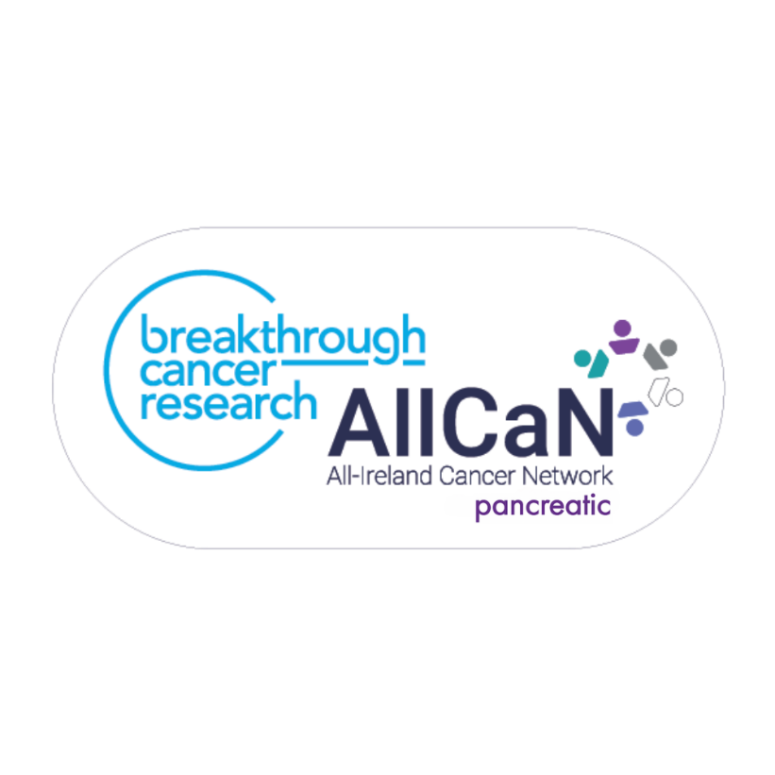

Pancreatic Cancer Research on the Island of Ireland

September 2024

Contents
Summary 3
Introduction 4
Breakthrough Cancer Research 5
Focus of Pancreatic Cancer Researchers on the Island of Ireland 5
Survey Findings 6
Pancreatic Cancer Symposium 10
Structure of the Symposium 10
Summery of presentations and panel discussions 11
Next Steps 14
Appendix 1: Pancreatic Cancer Symposium Programme 14

Summary
Pancreatic cancer is a poor prognosis cancer. Thirty-nine scientists, consultants and allied health professions actively in pancreatic cancer research on the Island of Ireland research, as well as four charities – Pancreatic Cancer Ireland, Northern Ireland Pancreatic Cancer, Pancreatic Cancer EU and Pancreatic Cancer UK were invited to join Breakthrough Cancer Research on June 27th 2024 for a Pancreatic Cancer Symposium. The theme of the Symposium was “Doubling Survival by 2045 – Building a Roadmap”, with the aim of understanding the strengths and opportunities in the research landscape across the island of Ireland that could be built upon, facilitated by strategic research funding, to improve pancreatic cancer outcomes.
At this networking event, we heard about the burden of pancreatic cancer in the Republic of Ireland and Northern Ireland, from the Directors of the two population-based cancer registries on the Island of Ireland. The devastating human impact of this disease was described by representatives from two of the pancreatic cancer charities on the island of Ireland with direct experience of this disease. Presentations from eleven groups leaders across the Island of Ireland described their pancreatic cancer research aims and expertise spanning the disease trajectory from the early detection of pancreatic cancer to treatment and supportive interventions. Finally, results of a survey investigating the pancreatic cancer landscape on the Island of Ireland described the breadth and depth of pancreatic cancer research, as well as the barriers and opportunities experienced.
The theme of the Symposium was “Doubling Survival by 2045 – Building a Roadmap”. During a panel discussion, participants were invited to reflect on the opportunities based on the research strengths to form a new pancreatic cancer research programme of work and an all-island team(s) to conduct it, as part of Breakthrough’s AllCaN – Pancreatic Cancer Programme.

Introduction
Pancreatic cancer is a poor prognosis cancer. Northern Europe has the highest pancreatic cancer incidence and mortality for both men and woman globally, see Figure 1 (Ilic et al., 2022).
Annually there are approximately 900 pancreatic cancer cases on the island of Ireland (n=600 RoI, n=279 NI) and 820 deaths (n=569 RoI, n=252 NI) according to figures from the National Cancer Registry Ireland (ncri.ie) and Northern Ireland Cancer Registry (qub.ac.uk).
The 5 year survival has increased slowly over the past decades, but remains very low at 14% in the Republic of Ireland (RoI; NCRI), and 7.9% in Northern Ireland (NI; NICR). Incidence is increasing in both the RoI and NI, and globally

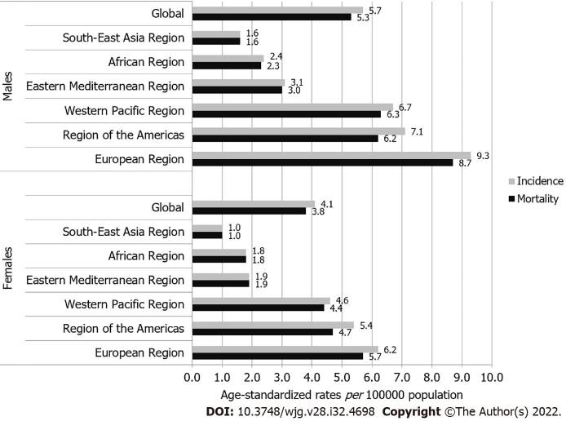
Figure 1. International patterns in incidence and mortality trends of pancreatic cancer in the last three decades

Breakthrough Cancer Research
Breakthrough Cancer Research (Breakthrough) are particularly focused on improving outcomes for those cancers, which are poorly served by current treatment options.
In 2022 we launched ‘Making More Survivors’ - Our Research Strategy 2022 - 2027 which sets out how, through research, we plan to significantly impact the survival rates of the poorest prognosis cancers over the next two decades, starting with this five year strategy. We believe in the power of research to transform cancer care and the patient’s experience.
Our focus on the poorest prognosis cancers means we need to urgently have impact to remove the disparity in cancer survival rates between the so-called ‘good’ cancers and ‘bad’ cancers. This strategy reflects our ambitious vision to strive for 100% survival for 100% of cancers through cutting edge patient-focused translational research at every point of the cancer journey. New diagnostics and better treatments are urgently needed. Building capacity and embedding research into the health system will increase the number of people who survive a cancer diagnosis and improve their quality of life during treatment and beyond.
A lack of research funding is one of the reasons why pancreatic cancer outcomes remain poor. In Europe, pancreatic cancer research receives less than 2% of cancer-related funding, and in the USA it is one of the most underfunded cancers relative to mortality burden (Cause for concern: the rising incidence of early-onset pancreatic cancer. The Lancet Gastroenterology & Hepatology, 2023 Volume 8, Issue 4, 287).
Breakthrough are addressing this need by strategically investing funding into research for the poorest prognosis cancers, including pancreatic cancer.

Focus of Pancreatic Cancer Researchers on the Island of Ireland
Breakthrough aims to build research capacity and excellence focused on the challenge of improving outcomes of the poorest prognosis cancers.
To understand the current research landscape and start to develop a roadmap towards improved pancreatic cancer patient outcomes through research we (i) sent a survey to 36 researchers across the Island of Ireland who had published pancreatic cancer research within the last ten years using the Qualtrics platform, and (ii) invited relevant stakeholders to a pancreatic cancer symposium on June 27th 2024.

Survey Findings
Survey responses were obtained from 22 researchers, giving a response rate of 61%. There is a pancreatic research focus in eight institutions across the island of Ireland, see Figure 2.

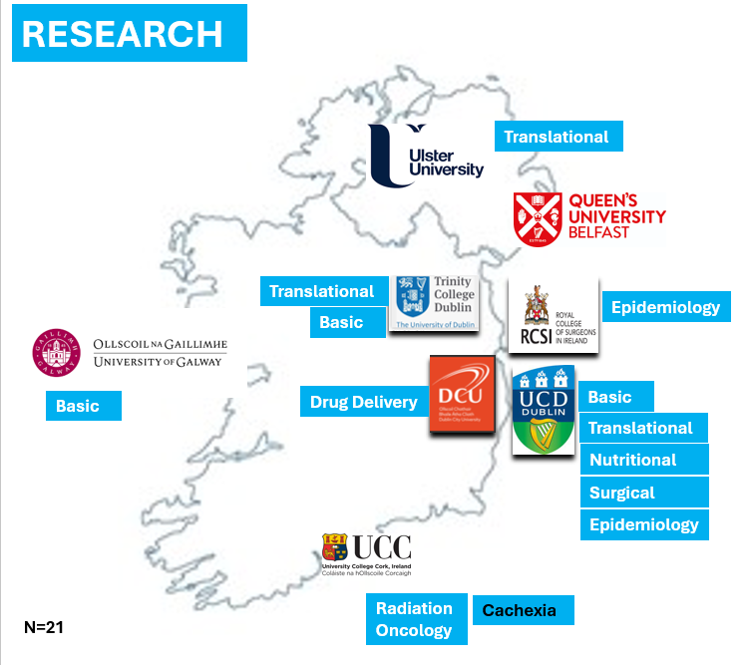

Figure 2. Pancreatic cancer research activity across the island of Ireland, 2024

The overarching research focus of the majority of research groups is pancreatic cancer treatment, followed by (early) detection, see Figure 3. University College Dublin is the institute currently undertaking the highest number of pancreatic cancer research projects, see Figure 3

Figure 3. The main focus (%) of pancreatic cancer research teams across the island of Ireland

Figure 4. The percentage of current pancreatic cancer research projects per institution across the island of Ireland
Among survey responders, across the island of Ireland there are only18 PhD students, 11 post-doctoral researchers, 3 research nurses and 1 technician working on pancreatic cancer research projects in 2024, see Figure 5

Figure 5. Number of researchers working on pancreatic cancer research projects across the island of Ireland in 2024.

While there are many researchers who report that there are no lack of skilled researchers, collaborations or access to tissue samples others experience these barriers, see Figure 6. The majority of responders to the survey report a lack of appropriate infrastructure, and research funding opportunities.

Figure 6. Number of researchers across the island of Ireland ‘agreeing/very much agreeing’ or ‘disagreeing/very much disagreeing’ that the listed opportunities and barriers listed impacted their pancreatic cancer research

Pancreatic Cancer Symposium

Structure of the Symposium
Thirty-nine scientists, consultants and allied health professions actively in pancreatic cancer research on the Island of Ireland research, as well as four charities – Pancreatic Cancer Ireland, Northern Ireland Pancreatic Cancer, Pancreatic Cancer EU and Pancreatic Cancer UK were invited to join Breakthrough Cancer Research on June 27th 2024 for a Pancreatic Cancer Symposium. The theme of the Symposium was “Doubling Survival by 2045 – Building a Roadmap”, with the aim of understanding the strengths and opportunities in the research landscape across the island of Ireland that could be built upon, facilitated by strategic research funding, to improve pancreatic cancer outcomes.
During the symposium a ‘speed dating’ approach was taken to gain a wide understanding of the research focus, expertise and resources on the island of Ireland (see Appendix 1).
We had presentations from 15 principal investigators, as well as the two population-based Cancer registries on the island of Ireland and three pancreatic cancer charities who presented their research focus, expertise.

Summary of presentations and panel discussions
There is multi-disciplinary expertise in addressing the unmet need of early detection and advancing treatment in pancreatic cancer across the island of Ireland, see Table 1.
It is recognised that there is a need for increased understanding of the aetiology and biology of this disease in order to advance primary prevention, early detection, optimum treatment and care pathways, which is necessary to ultimately improve pancreatic cancer outcomes, see Table 2.

Table 1: Overarching expertise, resources and opportunities of the pancreatic cancer researchers on the island of Ireland who attended the symposium

Challenges | Expertise & Opportunities | Institute
Early detection | Surveillance Clinic for high-risk individuals | St Vincents
 | NICR Datasets/linkage | QUB
 | N/S Registry collaboration | NICR/NCRI
 | Pancreatic Cancer Audit | NICR
 | New Pathway to Care for pancreatic cancer patients | NI
 | Surgical team / close working research groups | QUB/UCD (& affiliated hospitals)
 | - PRiCAN (Primary Care Research into Cancer) | RCSI
 | Research expertise in biomarker discovery | QUB, TSJCI, UCD
 | Clinical Risk Prediction Models | QUB, TSJCI
 | Immunobiology of pre-malignant disease | TSJCI
 | Biobanked cyst fluid & serum | TSJCI
Better treatment | Increase in percentage of patients accessing surgery | St Vincents
 | Respectability; Anatomical / Biologic / Clinical Features | St Vincents
Prehabilitation
Programmes prior to surgery
 | Nutritional interventions: FEED study | St Vincents
 | High Precision Radiotherapy trials | CUH/UCC  St Lukes Hospital  Irish Research Radiation Oncology Group (IRROG)
 | PROMS/QoL studies | CUH/UCC
 | Research expertise on biomarker discovery to (i) predict treatment response; (ii) monitor treatment response/treatment resistance; (iii) alert to recurrence | QUB, TSJCI, UCD
 | Investigating the role of the microbiome, associated metabolites and gut barrier integrity in pancreatic cancer development | DCU, UCC
 | Access to biobanks, large international population cohort infrastructures, patient cohort studies | QUB, TJSJI, DCU, UCD
 | Molecular mechanisms of treatment resistance in PDAC – novel therapeutics | TSJCI
 | Expertise in Mechanobiology and the Tumour Microenvironment – biomarker and targeted treatment strategies | UCD
 | Immunobiology of pre-malignant disease | TSJCI
 | Treatment delivery systems; (i) Carbon nanoparticles (ii) Ultrasound activated Drug Loaded microbubbles | DCU  Ulster University
 | Unfolded protein response  Hypoxia response | UCD
 | Clinical Trials- translational focus | - Phase II AZD 0171 in advanced PDAC (Global PI)  - Phase II trial of BOLD-100 (Unfolded protein response)  - DORA: Durvalumab & oleclumab (WOO)  - DP-IMRT – dose escalation Ph II study
 | Epidemiology | RCSI/QUB
 | NICR Datasets/linkage | QUB
 | N/S Registry collaboration | NICR/NCRI

TSJCI: Trinity St Jame’s Cancer Institute
QUB: Queens University Belfast
UCD: University College Dublin
UCC: University College Cork
DCU: Dublin City University
NICR: Northern Ireland Cancer Registry
NCRI: National Cancer Registry Ireland
CUH: Cork University Hospital

Table 2: Research challenges that need to be addressed to improve pancreatic cancer outcomes on the island of Ireland
To improve pancreatic cancer outcomes, research is required in;

- Increasing understanding of pancreatic cancer biology from normal pancreatic tissue to pre-malignancy, early disease, late disease & treatment resistance

- Understanding the pathogenesis of pancreatic cancer across population groups

- Understanding risk factors for primary prevention

- Biomarker discovery and use for early detection

- Risk stratification

- Surveillance of high-risk individuals

- Optimal treatment - prehabilitation, holistic approach to suitability for resection, improved precision approaches to chemotherapy, understanding the optimal role of radiotherapy

- Treatment discovery for primary disease and resistant disease

- Improved methods of treatment delivery

- Understanding the optimal pathways of care across the disease trajectory

Next Steps
Breakthrough are launching our AllCaN Pancreatic Cancer Grant Programme Call 2024. We are calling on leading experts in pancreatic cancer to bring together a new team of leading researchers, clinicians, PPIE, charities, industry and policy makers across the island of Ireland to develop a new research programme aimed at addressing some of these pressing unmet clinical needs towards improving pancreatic cancer outcomes.

Appendix 1: Pancreatic Cancer Symposium Programme
Pancreatic Cancer Symposium
The theme of the symposium is: “Doubling Survival by 2045 – Building a Roadmap”
June 27th , 1-5 pm
Citi Offices, Flr G, Experience Room, 1 North Wall Quay, Dublin

1.00-1.45 Lunch & Welcome. Chair; Dr Frances Drummond
1.45-1.50 Orla Dolan, CEO Breakthrough Cancer Research
1.50-2.05: Burden of Pancreatic Cancer – Trends, lessons & opportunities (15)
1.50-1.57: Prof Deirdre Murray, Director National Cancer Registry Ireland
1.57-2.04: Dr Damian Bennett, Director Northern Ireland Cancer Registry
2.05-2.20: impact of Pancreatic Cancer (15)
2.05-2.12: Mr Niall Rochford, Co-founder, Pancreatic Cancer Ireland
2.12-2.19: Mr Ivan McMinn MBE, Chairperson Northern Ireland Pancreatic Cancer (NIPANC)
2.20-2.25: AllCaN Programme – Oesophageal Cancer
2.20-2.25: Prof Jacintha O’Sullivan, Trinity St. James Cancer Institute, “Leading AllCaN – Oesophageal Cancer”
2.30: Prevention/Early Detection
2.30-2.35: Associate Professor Patrick Redmond, Royal College of Surgeons of Ireland, “Advancing Prevention and Early Detection of Pancreatic Cancer in Primary Care”
2.35-2.40: Associate Professor Stephen Maher, Trinity Translational Medicine Institute, “Multiomic biomarkers for risk stratification in pre-malignant pancreatic disease”

2.40-2.45: Dr Richard Turkington: Patrick G Johnston Centre for Cancer Research, Queens University Belfast, “Early Detection of Pancreatic Cancer utilising the DNA Methylome”
2.45-2.50: Associate Professor David Hughes/Neil Daniel, University College Dublin, “Investigating the role of the microbiome, associated metabolites and gut barrier integrity in pancreatic cancer development”
2.50-2.55: Prof Lorraine O'Driscoll, Trinity College Dublin, “The All Ireland Cancer Liquid Biopsies Consortium (CLuB) – moving toward earliest possible detection and best treatment selection for pancreatic cancer”
3:00: Treatment
3:00-3.05: Prof Tom Gallagher, St Vincent’s University Hospital, “Current Surgical Standards for PDAC”
3.05-3.10: Prof Aisling Barry, University College Cork “Radiotherapy for Pancreatic Cancer”
3.10-3.15: Assistant Professor Stephen Thorpe, University College Dublin, “Mechanotherapeutics for pancreatic cancer”
3.15-3.20: Prof Silvia Giordanni, Dublin City University, /Dr Sofia Dominguez Gill, Dublin City University, “Carbon nanoparticles for treatment delivery”
3.20-3.25: Assistant Professor Claire Robinson, University College Dublin, “Understanding the unfolded protein response in the PDAC stroma”
3.25-3.30: Prof. John Callan, Ulster University, “Ultrasound targeted drug loaded microbubbles for the treatment of pancreatic cancer”.
3.30-3.35: Associate Professor Naomi Walsh, Dublin City University, "Pancreatic cancer drug response and resistance".
3.40-3.45: Prof. Grainne O’Kane, Pat Smullen Chair in Pancreatic Cancer “Chemotherapy and pancreatic cancer”
3.45-3.50: Dr Oonagh Griffin, Senior Pancreatic Cancer Dietitian, St Vincent’s University Hospital: The FEED Trial
Break 3:50-4.00
4:00-5:00 Research landscape & panel discussion
4.00-4.05: Dr Frances Drummond, Breakthrough Cancer Research “Survey of Pancreatic cancer research on the Island of Ireland”
4.05-4.10 Raquel Benitez, Project Officer, Pancreatic Cancer EU “Research map and on the PancreOS Project”
4.10-5.00 Panel Discussion & “Building a Roadmap”

